Individual Portfolio Phase 2

Billy Hodges – 30021362

<https://github.com/PeterColburn/Team1>

# Week 1: 10/01/2022

|  |  |
| --- | --- |
| Week 1 |  |
| Activities Set | Discuss and start creating presentation slides |
| Outcomes of QA activities | I took part in a discussion where we decided the roles of our upcoming PowerPoint presentation reach our goals for the presentation.  The activity I had was to research and start to create my slides for our presentation. These slides were, what we learned, and how did we apply this feedback. |
| Results from QA activities | I managed to get a clear vision of what I was doing in the presentation and when it had to be done by. |
| Evidence of activities | See appendix: |

# Week 2: 17/01/2022

|  |  |
| --- | --- |
| Week 2 |  |
| Activities Set | Finish What did we learn and how did we apply to our project PowerPoint slides. |
| Outcomes of QA activities | This week I finished my slides on what we learned about communication and how we applied it to our project. I then presented this presentation with the rest of my group. The slide look basic as I did not want to overload the user with information instead choosing to read from a card of bullet points Infront of me.  I also watched and Seminar from Group 2 Team 1, about Programming Languages |
| Results from QA activities | The Presentation went well and we received mostly positive feedback however were told we could improve on were we stood. |
| Evidence of activities | See appendix: |

# Week 3: 24/01/2022

|  |  |
| --- | --- |
| Week 3 |  |
| Activities Set | Watched Other Groups Seminars, these were:  Seminar: Group 1 Team 2 – Payroll  Seminar: Group 2 Team 2 – Health fitness app  Seminar: Group 2 Team 3 – Organisation Tool |
| Outcomes of QA activities | Focused on reflection on phase 1 and current work and preparation for upcoming activities. |
| Results from QA activities | Due to Illness was unable to attend tutorial |
| Evidence of activities | See appendix: |

# Week 4: 31/01/2022

|  |  |
| --- | --- |
| Week 4 |  |
| Activities Set | Reflected on Previous Seminars and gave feedback on:  Group 1 Team 3 – Library Management System  Group 1 Team 4 – Security Authentication  Group 3 AI Team 1 - Face |
| Outcomes of QA activities | I watched other Group Seminars and reflected on what they had done well and what they could improve on. |
| Results from QA activities | This week helped me acquire new knowledge from other presentations and I incorporated some of this into my workflow. |
| Evidence of activities | See appendix: |

# Week 5: 07/02/2022

|  |  |
| --- | --- |
| Week 5 |  |
| Activities Set | Split up Vulnerability Work and start researching for it |
| Outcomes of QA activities | I took part in a discussion in which we decided to split up the vulnerability document to different People. It was decided that I would do privilege attack. I then started researching this. |
| Results from QA activities | I greatly developed my knowledge of privilege vulnerabilities and explore how we can defend against them better. Also Improved referencing work. |
| Evidence of activities | See appendix: |

# Week 6: 14/02/2022

|  |  |
| --- | --- |
| Week 6 |  |
| Activities Set | To Finish Writing about Privilege Confusion. |
| Outcomes of QA activities | This week I finished researching the for the privilege attack and wrote about wrote up my knowledge I had learned about in the Vulnerability Document |
| Results from QA activities | This showed the strength the current state of our program and as a group we investigated protection for vulnerabilities. |
| Evidence of activities | See appendix: |

# Appendix

## Week 1: Evidence

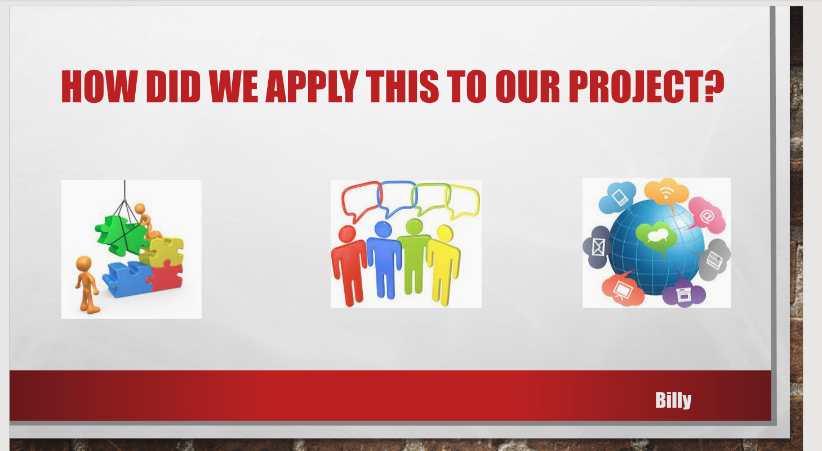

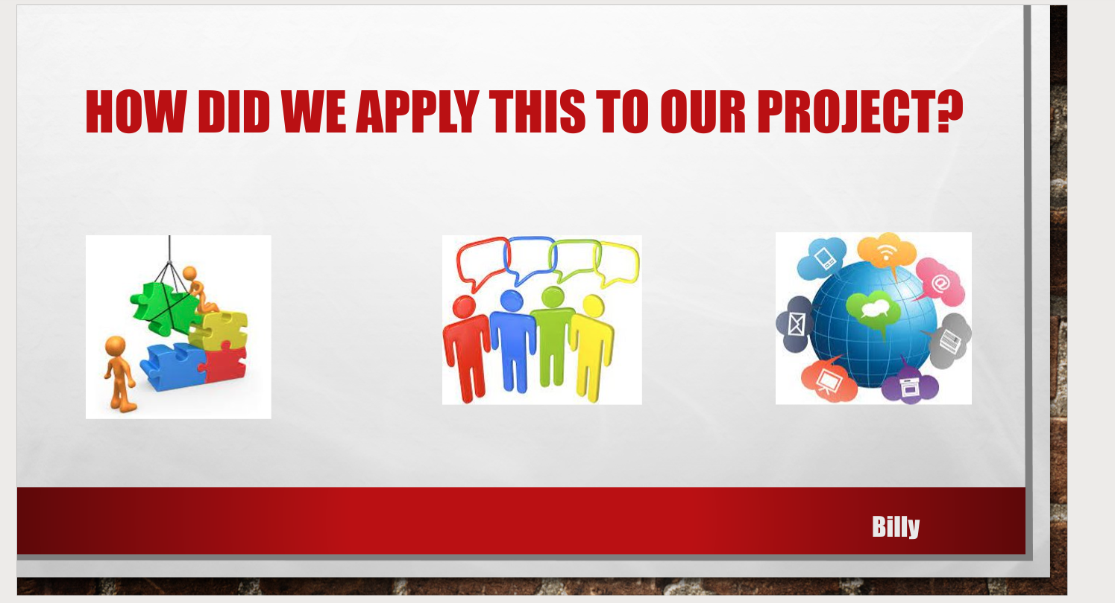

## Week 2 Evidence

N/A (Same as week 1)

## Week 3 Evidence

N/A

## Week 4 Evidence

N/A

## Week 5 Evidence – see VulnerabilityDoc on GitHub for more

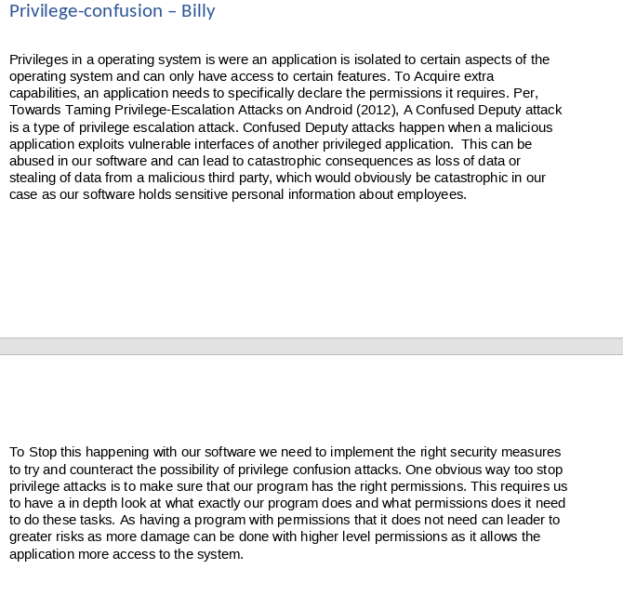

## Week 6 Evidence

N/A